LAB EXPERIMENTS

Experiment-1
Aim
To develop a simple cloud-based Flight Reservation System using a Cloud Service Provider and demonstrate the SaaS model.
Procedure
- Select a Cloud Service Provider such as AWS, Microsoft Azure, or Google Cloud to host the Flight Reservation application.
- Design the application interface with fields such as One Way/Round Trip, From, To, Departure Date, Return Date, Travelers, Class, Fare Type, and Domestic/International.
- Develop the web application using HTML, CSS, and JavaScript to create the flight search and reservation interface.
- Add input validation to ensure that users enter all required details correctly before searching for flights.
- Implement flight search functionality to display sample flight details such as airline, flight number, departure time, arrival time, duration, and fare.
- Implement reservation functionality to allow users to select a flight, enter passenger details, and generate a booking confirmation.
- Deploy the application on the cloud and store flight/reservation data using a suitable cloud database or storage service.
- Test and demonstrate the SaaS application by accessing it through a web browser and verifying One Way, Round Trip, Domestic, International, traveler, class, fare, and reservation features.

Output:
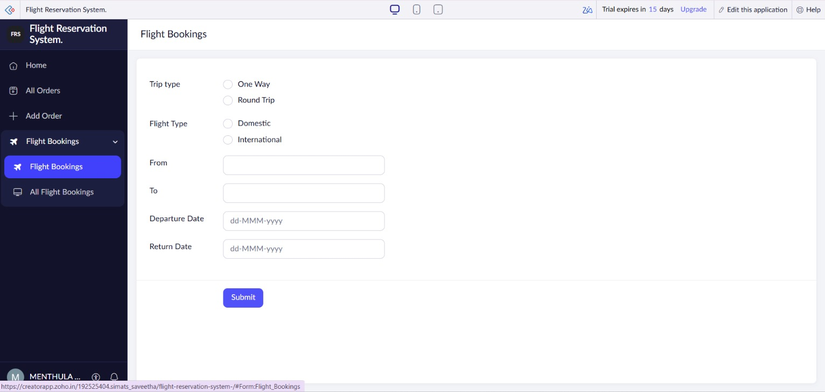
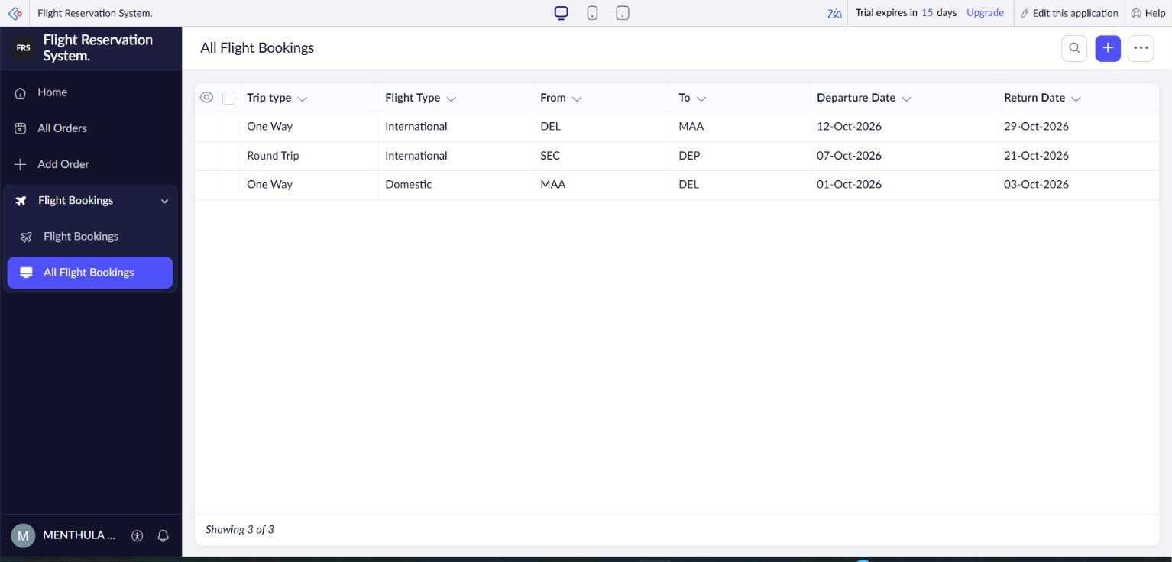

Result:
The Flight Reservation System was successfully developed and deployed on a cloud platform.It allows users to search and reserve domestic/international flights with different trip, class, and fare options. Thus, the application successfully demonstrates the Software as a Service (SaaS) model.

Experiment-2
Aim
To develop and deploy a simple cloud-based Property Buying and Rental System for Chennai using a Cloud Service Provider to demonstrate the Software as a Service (SaaS) model.
Procedure
- Select a Cloud Service Provider such as AWS, Microsoft Azure, or Google Cloud to host the application.
- Design the application interface with options such as Buy, Rent, Commercial, and Rental Agreement.
- Add property details including Area, Place, Property Type, Range, Property Value, and Rental Price.
- Develop the web application using HTML, CSS, and JavaScript for searching and displaying properties.
- Implement search functionality to allow users to search properties based on place, area, range, and property type.
- Implement property details and rental agreement features to display property information and rental agreement details.
- Deploy the application on the cloud and store property and user information using a suitable cloud database.
- Test the SaaS application by searching for properties in different areas of Chennai and verifying the Buy, Rent, Commercial, and Rental Agreement features.
Output:

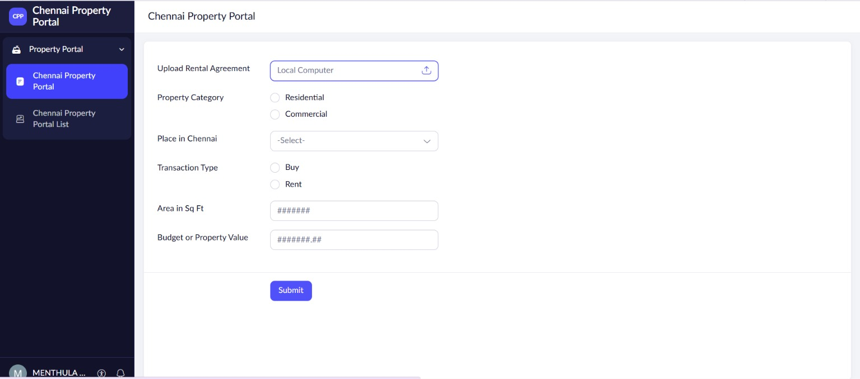
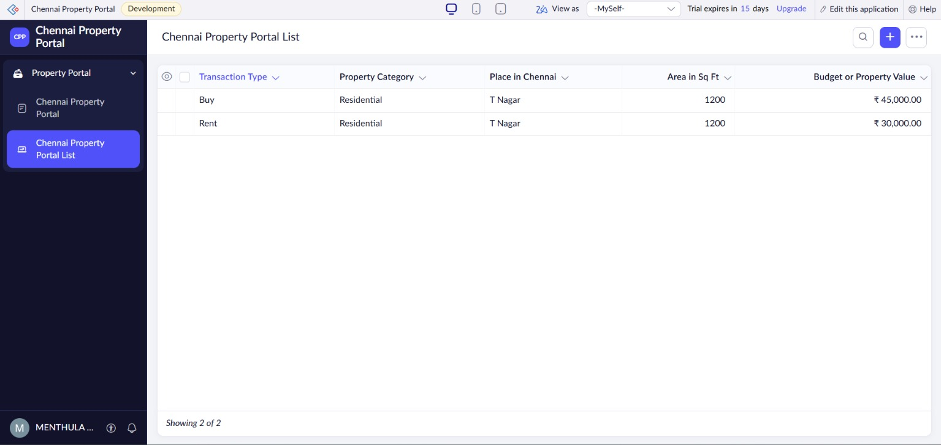

Result
The cloud-based Property Buying and Rental System for Chennai was successfully developed and deployed.The application provides Buy, Rent, Commercial, Area, Place, Range, Property Value, and Rental Agreement features.Thus, the application successfully demonstrates the Software as a Service (SaaS) model.

Experiment-3
Aim:
To create a simple cloud-based Car Booking Reservation System using a Cloud Service Provider to demonstrate Software as a Service (SaaS) with cab search, booking type, source, destination, package type, and rental duration.
Procedure:
- Select a cloud service provider such as Zoho Creator and create a new cloud application.
- Create a Car Booking Reservation form in the application.
- Add fields such as Search for Cabs, From, To, Booking Type, Package Type, Hours/Days, and Car Type.
- Provide booking types such as Rental and Out Station.
- Add suitable options for package duration, such as number of hours or days.
- Configure the form to allow users to enter their travel and booking details.
- Save and deploy the application on the cloud so that it can be accessed through a web browser.
- Test the application by entering booking details and verifying that the reservation information is stored successfully.
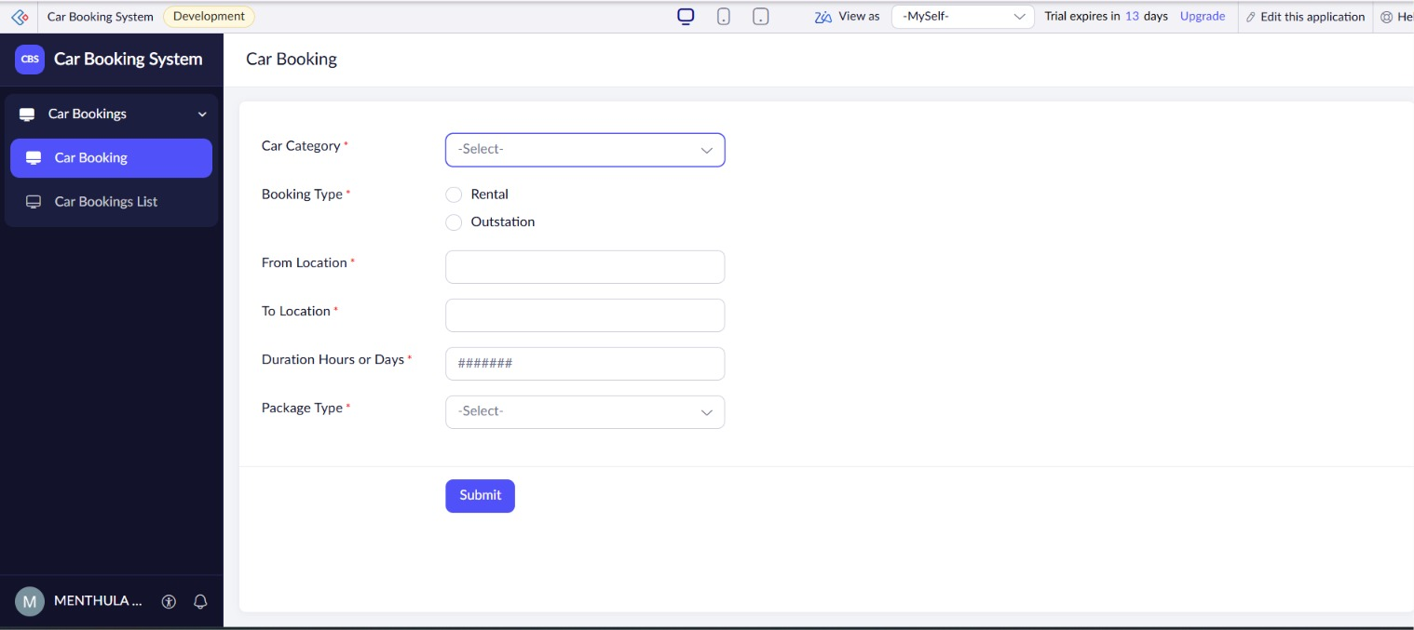
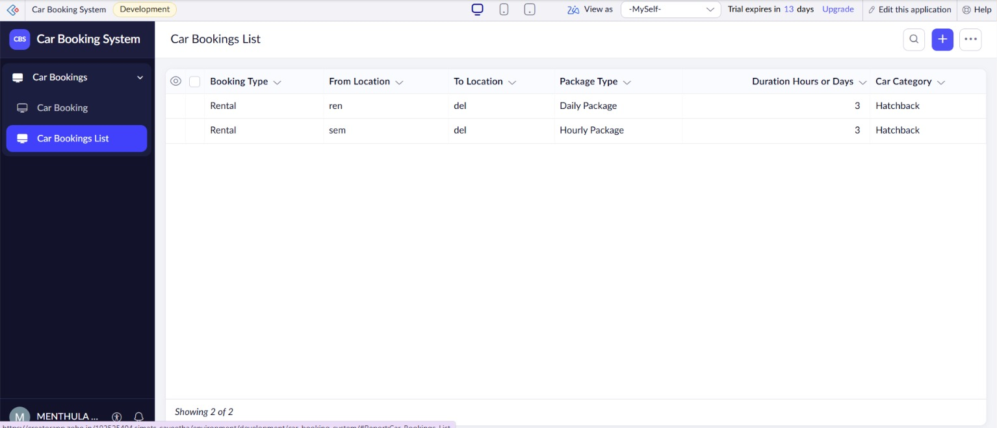

Result:
The Car Booking Reservation System was successfully created as a cloud-based SaaS application. Users can search and book cabs by entering From, To, Rental/Out Station, Package Type, and Hours/Days details.

Experiment-4
Aim:
To create a simple cloud-based Library Book Reservation System for the SIMATS Library using a Cloud Service Provider to demonstrate Software as a Service (SaaS).
Procedure:
- Select a Cloud Service Provider such as Zoho Creator and create a new cloud application.
- Create a Library Book Reservation form in the application.
- Add fields such as Title of the Book, Author, Publication, Year, Edition, and Number of Copies.
- Add a Rack Number field to identify the location of each book.
- Add a Status field with options such as Taken and Returned.
- Configure the form to allow library staff to enter and update book details.
- Deploy the application on the cloud so that it can be accessed through a web browser.
- Test the system by adding book records and updating the status when books are taken or returned.
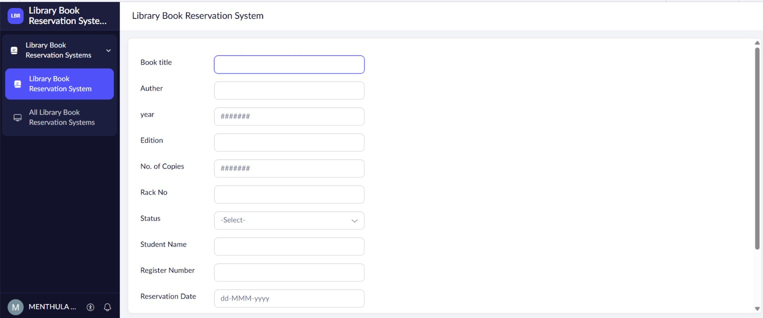
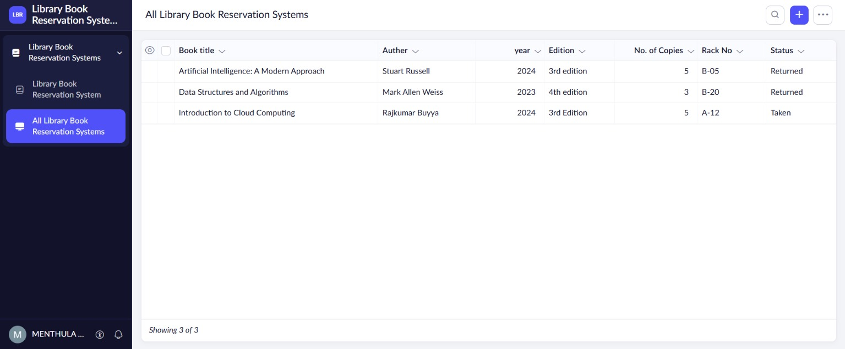
Result
The SIMATS Library Book Reservation System was successfully created as a cloud-based SaaS application. It allows users to maintain and manage book

Experiment-5
Aim:
To create a simple cloud-based Mark Sheet Processing System using a Cloud Service Provider to demonstrate Software as a Service (SaaS) for managing student marks and academic performance.
Procedure:
- Select a Cloud Service Provider such as Zoho Creator and create a new cloud application.
- Create a Mark Sheet Processing form in the application.
- Add fields such as Student Name, Register Number, Subjects, and Marks.
- Enter the marks obtained by the student for each subject.
- Configure the system to calculate the Average and Percentage automatically.
- Add fields for Rank and Overall Performance based on the student's marks.
- Deploy the application on the cloud so that it can be accessed through a web browser.
- Test the system by entering student marks and verifying the calculated results.
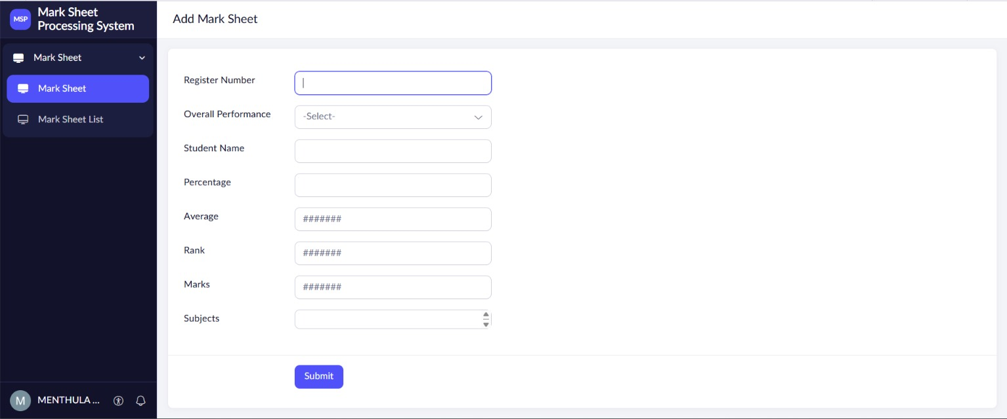
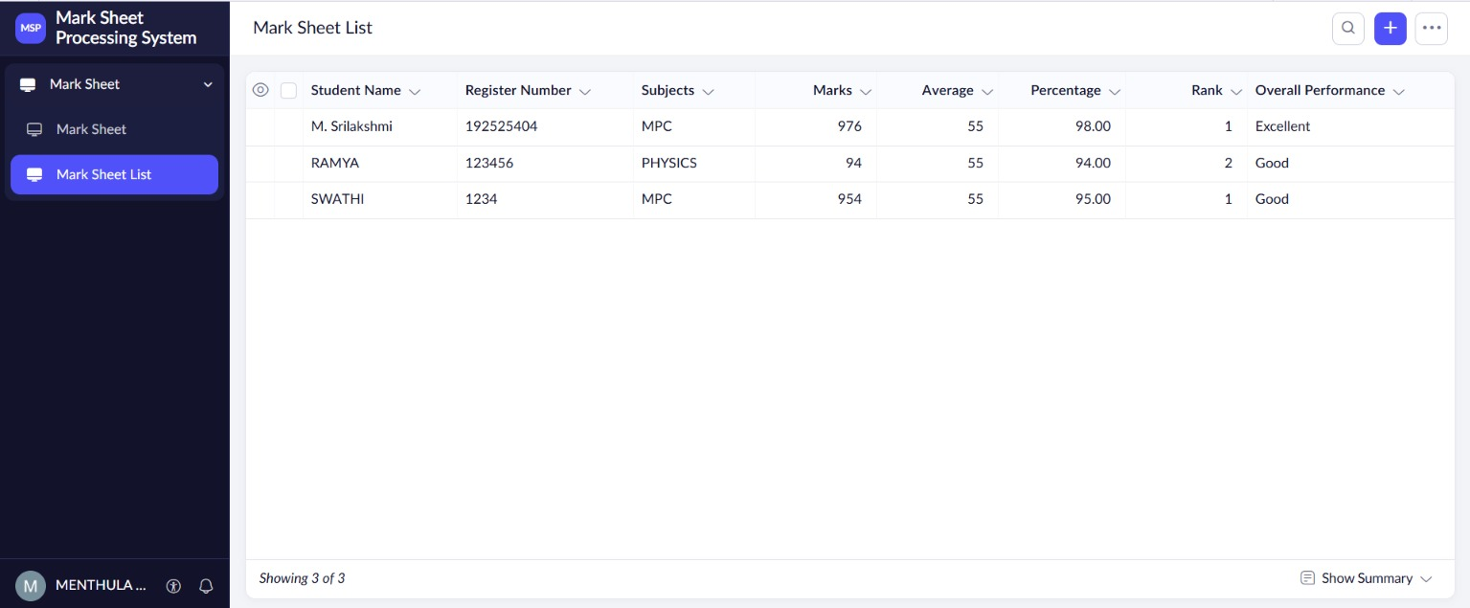
Result
The Mark Sheet Processing System was successfully created as a cloud-based SaaS application. It allows users to store student details and marks and process average, percentage, rank, and overall performance efficiently.
Experiment-6
Aim:
To create a simple cloud-based Payroll Processing System using a Cloud Service Provider to demonstrate Software as a Service (SaaS) for managing employee salary and payroll details.
Procedure:
- Select a Cloud Service Provider such as Zoho Creator and create a new cloud application.
- Create an Employee Payroll Processing form in the application.
- Add fields such as Employee Name, Employee ID, Experience in Present Organization, and Overall Experience.
- Add salary components such as Basic Pay, HRA, DA, and TA.
- Configure the system to calculate the Gross Pay using the salary components.
- Configure deductions and calculate the Net Pay for each employee.
- Deploy the application on the cloud so that employee payroll details can be accessed and managed online.
- Test the system by entering employee and salary details and verifying the calculated Gross Pay and Net Pay.
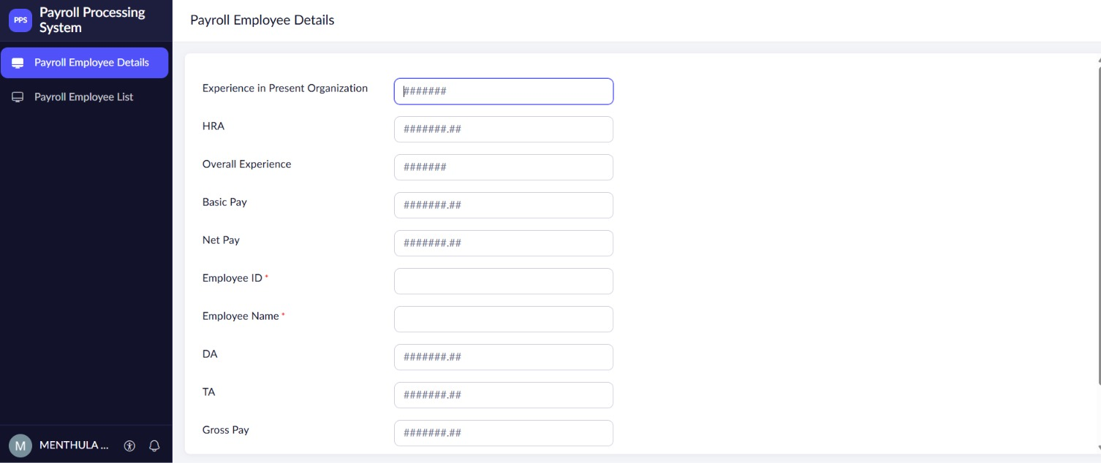
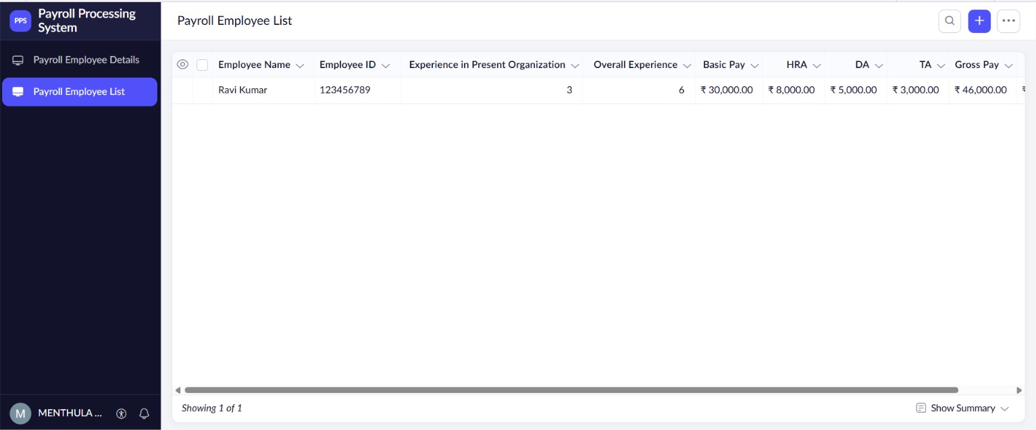
Result
The Payroll Processing System was successfully created as a cloud-based SaaS application. It allows users to manage employee details and salary components such as Basic Pay, HRA, DA, TA, Gross Pay, and Net Pay efficiently.

Experiment-7
Aim:
To create a simple cloud-based Student Attendance System using a Cloud Service Provider to demonstrate Software as a Service (SaaS) for managing and monitoring student attendance records.
Procedure:
- Select a Cloud Service Provider such as Zoho Creator and create a new cloud application.
- Create a Student Attendance form in the application.
- Add fields such as Student Name, Register Number, Course, and Attendance Date.
- Add attendance options such as Present, Absent, and OD (On Duty) Request.
- Record the attendance status for each student and course.
- Configure the system to calculate the Course Attendance and Attendance Percentage automatically.
- Add a Grade field based on the student's attendance percentage and deploy the application on the cloud.
- Test the system by entering student attendance details and verifying the calculated attendance percentage and grade.
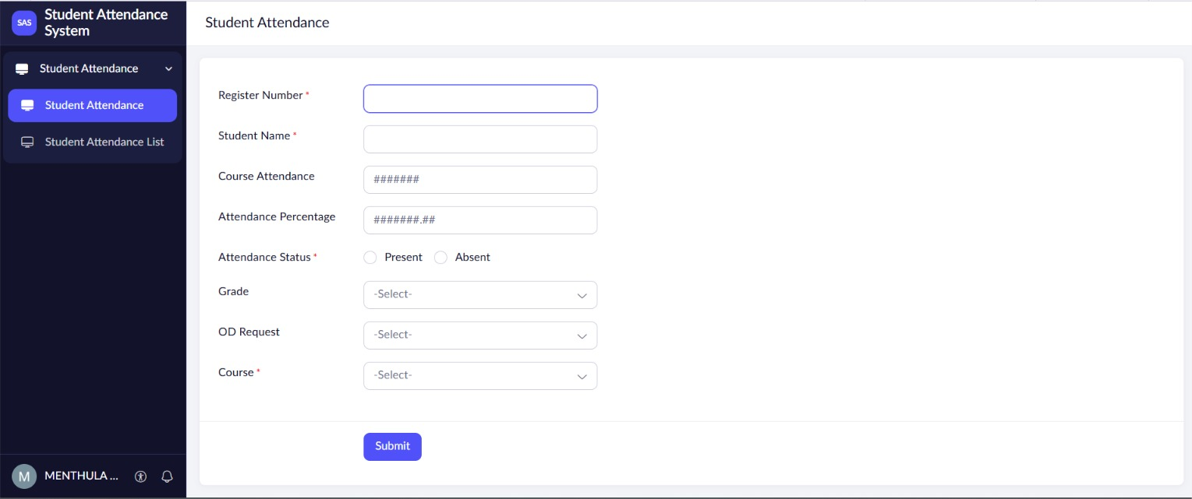
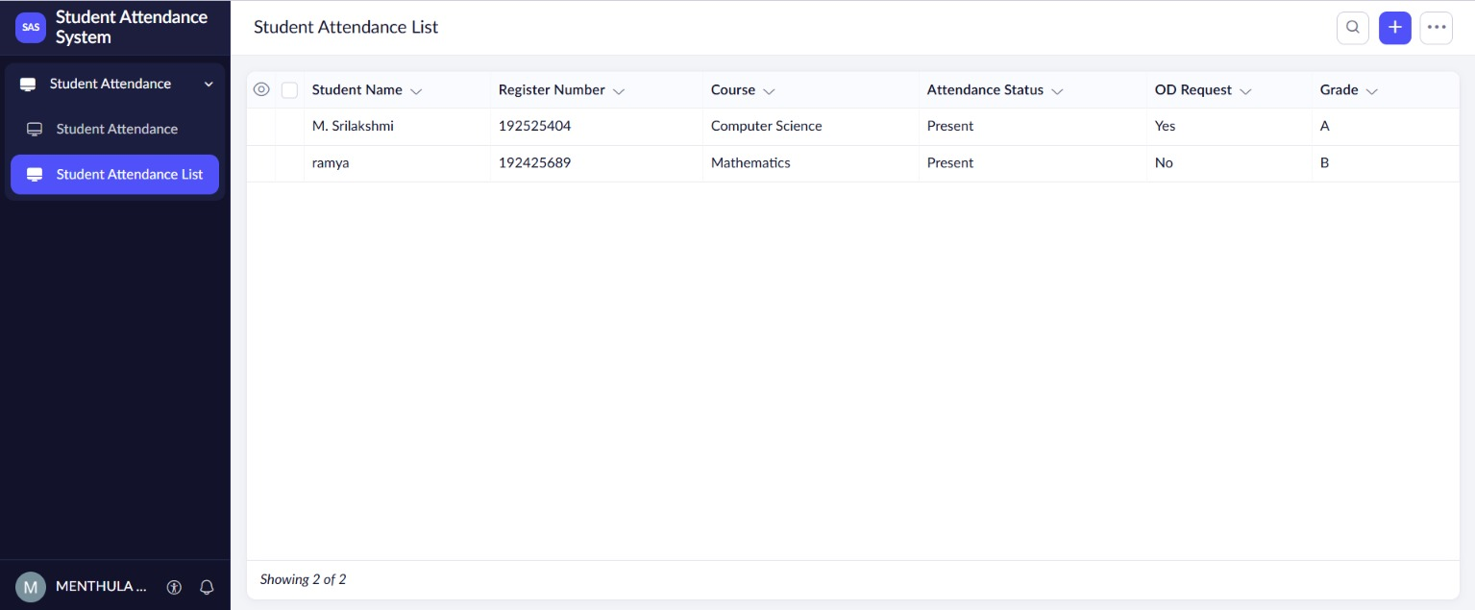
Result
The Students Attendance System was successfully created as a cloud-based SaaS application. It allows users to record Present, Absent, OD requests, course attendance, attendance percentage, and grade and manage student attendance online.

Experiment-8
Aim:
To create a simple cloud-based Student Counselling System using a Cloud Service Provider to demonstrate Software as a Service (SaaS) for maintaining student academic and counselling information.
Procedure:
- Select a Cloud Service Provider such as Zoho Creator and create a new cloud application.
- Create a Student Counselling form in the application.
- Add fields such as Student Name, Age, Address, and Phone Number.
- Add academic details such as Subjects Studied, Year of Passing, and Percentage of Marks.
- Add a Domain Interest field to record the student's preferred career or study domain.
- Configure the form to allow counsellors to enter and update student information.
- Deploy the application on the cloud so that the counselling records can be accessed through a web browser.
- Test the application by entering student details and verifying that the information is stored and displayed correctly.
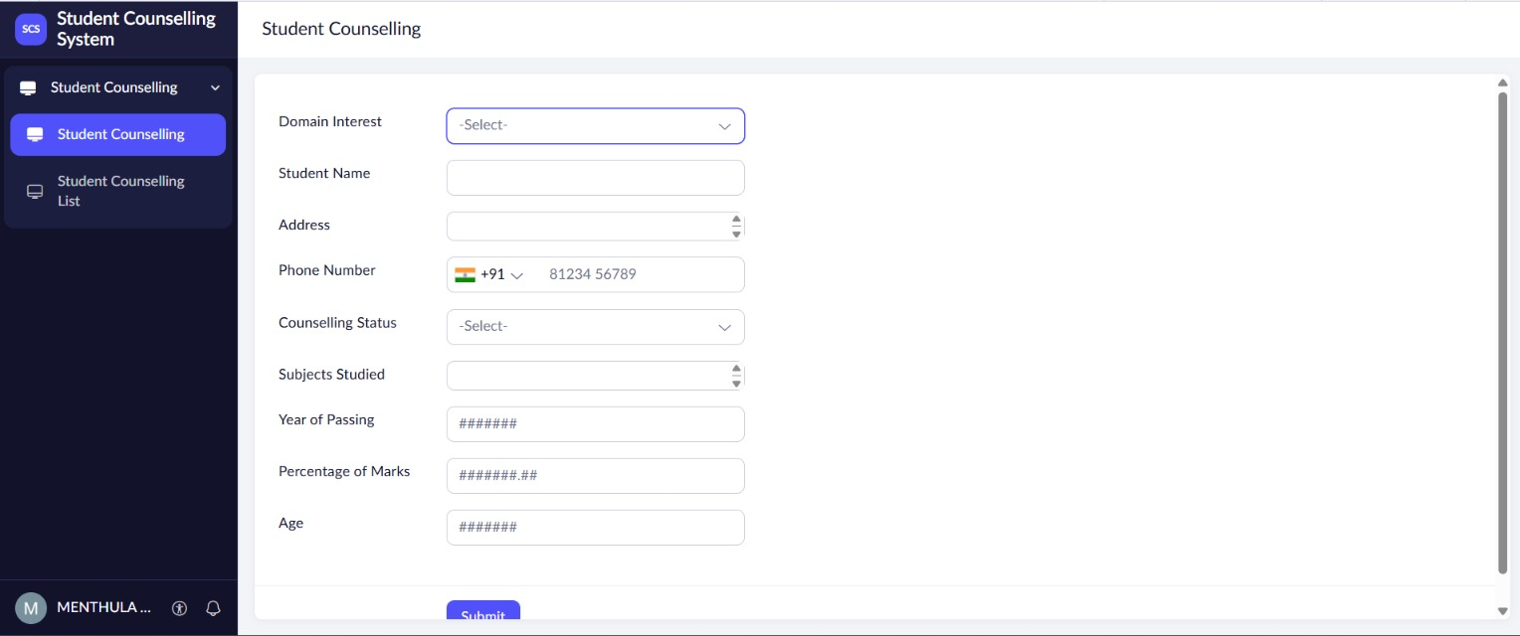
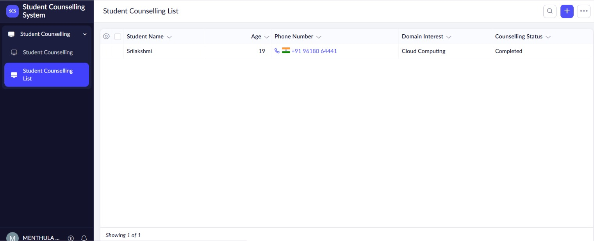
Result
The Student Counselling System was successfully created as a cloud-based SaaS application. It allows counsellors to manage student personal details, academic information, percentage of marks, and domain interests efficiently through the cloud.

Experiment-9
Aim:
To create a simple cloud-based Hospital Information System for SIMATS Hospital using a Cloud Service Provider to demonstrate Software as a Service (SaaS) for managing patient and hospital information.
Procedure:
- Select a Cloud Service Provider such as Zoho Creator and create a new cloud application.
- Create a Hospital Information form in the application.
- Add patient details such as Patient Name, Age, Address, Phone, and Email.
- Add attendant details such as Attender Name and Attender Phone.
- Add Doctor Name to record the doctor assigned to the patient.
- Add a Disease/Health Condition field to record the patient's medical information.
- Deploy the application on the cloud so that authorized hospital staff can access and manage the records online.
- Test the system by entering patient and doctor details and verifying that the information is stored correctly.
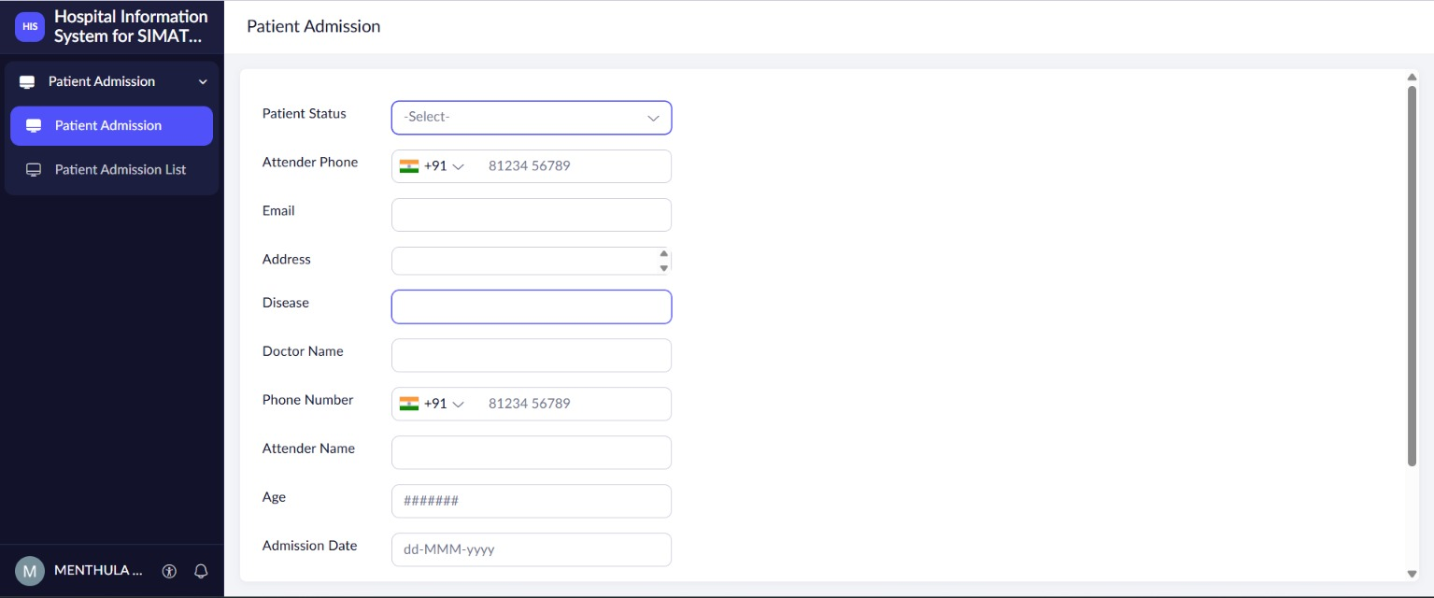
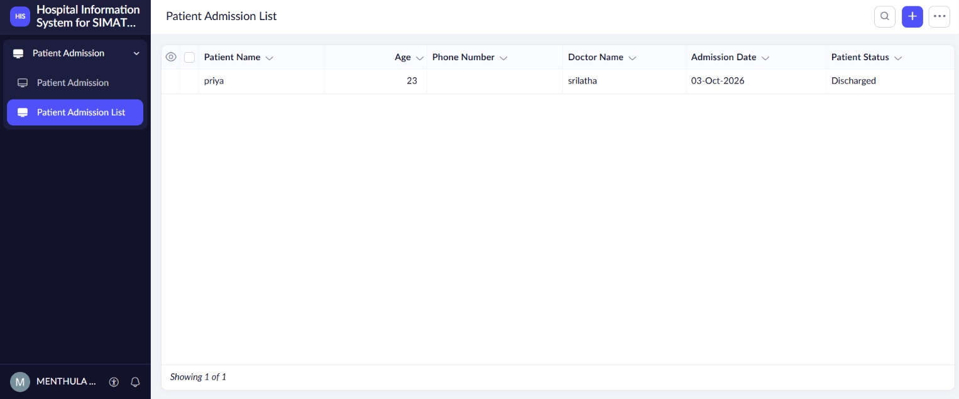
Result
The SIMATS Hospital Information System was successfully created as a cloud-based SaaS application. It enables authorized staff to manage patient, attendant, doctor, and disease information efficiently through the cloud.

Experiment-10
Aim:
To create a simple cloud-based Student Information System using a Cloud Service Provider to demonstrate Software as a Service (SaaS) and display student information using a C program.
Procedure:
- Select a Cloud Service Provider such as OnlineGDB or another cloud-based C programming platform.
- Create a new C program in the online cloud compiler.
- Define fields for Student Name, Register Number, Address, Phone, Age, and Courses.
- Add fields for Grades and Attendance Report to store academic performance.
- Add a Progress Report section to display the student's overall academic progress.
- Add a Semester Mark Sheet section to display subject-wise marks and results.
- Compile and run the C program in the cloud platform to display all student information.
- Test the application by entering sample student details and verifying that the complete information is displayed correctly.
Output:
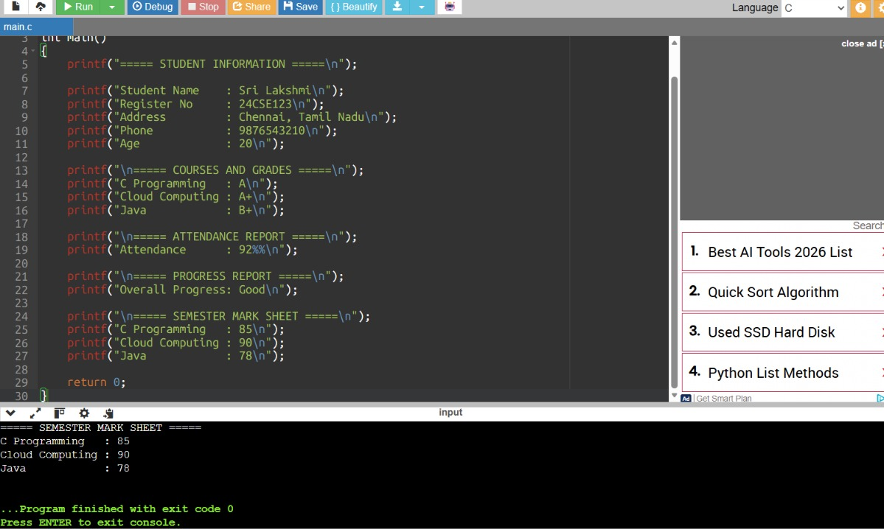

Result
The Cloud-based Student Information System was successfully created and executed using a C program. It displays student personal details, courses, grades, attendance, progress report, and semester mark sheet through a cloud-based SaaS environment.

Experiment -11
Aim:
To create a simple cloud-based Online Supermarket Application using a Cloud Service Provider to demonstrate Software as a Service (SaaS) for managing customer and product details.
Procedure:
- Select a Cloud Service Provider such as Zoho Creator and create a new cloud application.
- Create a Customer Details form in the application.
- Add fields such as Customer Name, Address, Phone Number, and Email.
- Create an Item Classification form to organize supermarket products into categories.
- Add fields such as Item Name, Item Category, Price, and Quantity.
- Allow customers to select items and enter the required quantity.
- Deploy the application on the cloud so that customers can access it through a web browser.
- Test the application by entering customer and item details and verifying that the information is stored correctly.
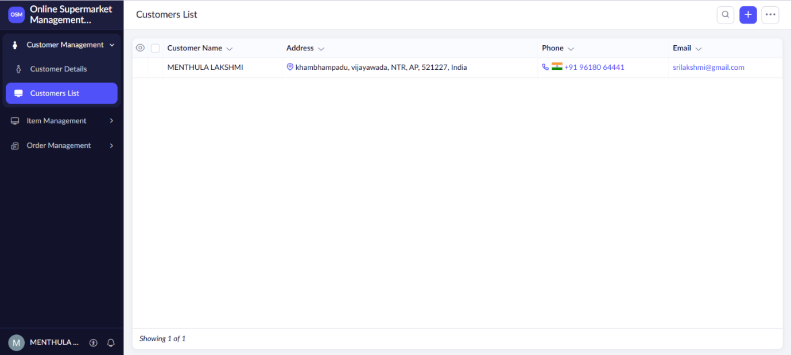
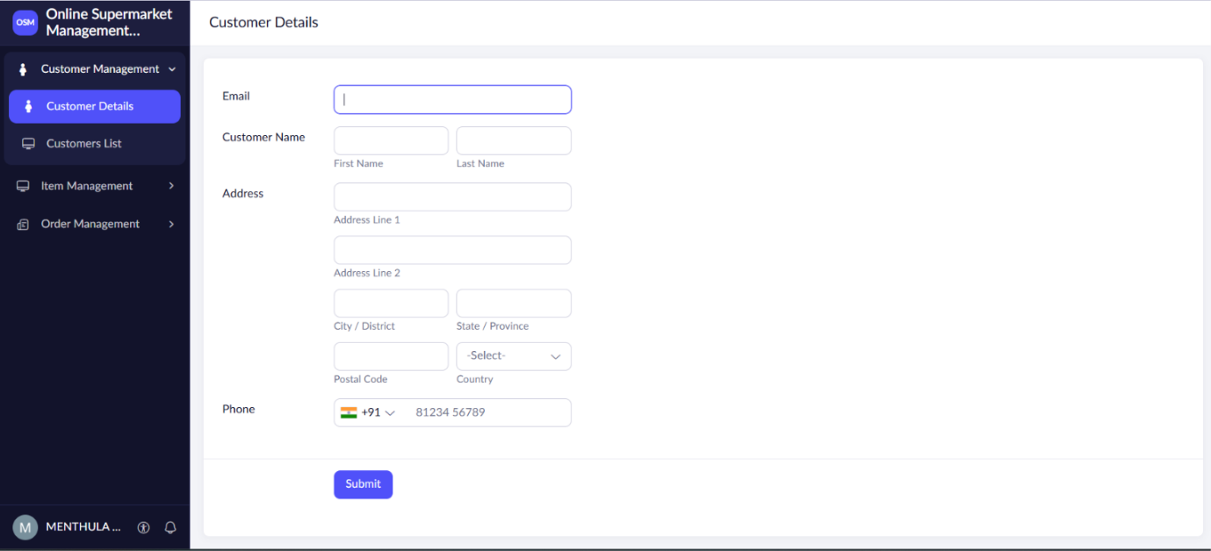
Output:

Result
The Online Supermarket Application was successfully created as a cloud-based SaaS application. It allows users to manage customer details, item classification, selected items, and quantities online through the cloud.

